Week 5: Payment Transaction Management System
Scenario: In a customized gifts business, customers place orders for different products. After placing an order, the customer makes a payment using methods such as UPI, Card, Cash, or Net Banking. The system records each payment and identifies whether the payment is Successful, Failed, or Pending. Failed payments can be updated after a successful retry.
Table Name: PAYMENT_ENTITY
Attributes
- Payment _ID – Unique ID for each payment.
- Order _ID – Identifies the related order.
- Payment _Date – Date of payment.
- Payment _Mode – UPI, Card, Cash, or Net Banking.
- Payment _Status – Success, Failed, or Pending.
- Transaction Amount – Amount paid by the customer.
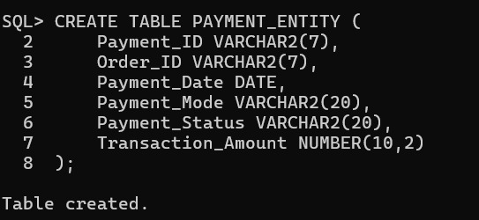
Establish Relationship and constraints:
Primary Key:
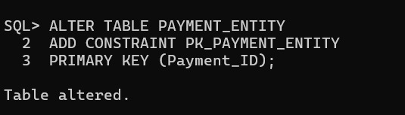
Foreign Key:
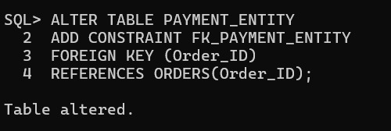
NOT NULL:
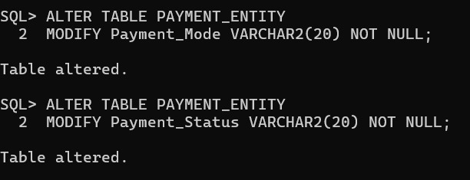
CHECK:
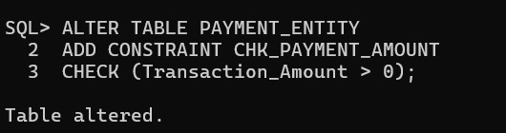
Insert values: 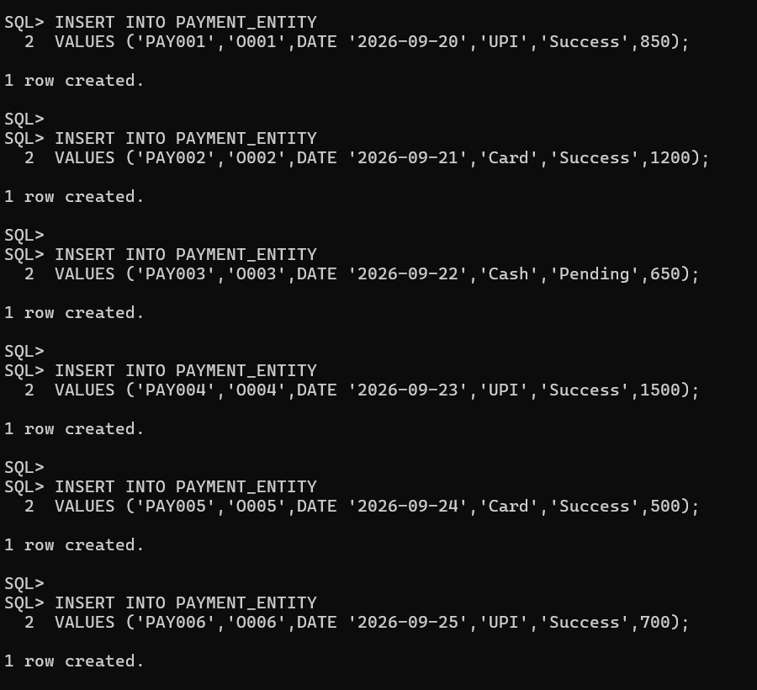
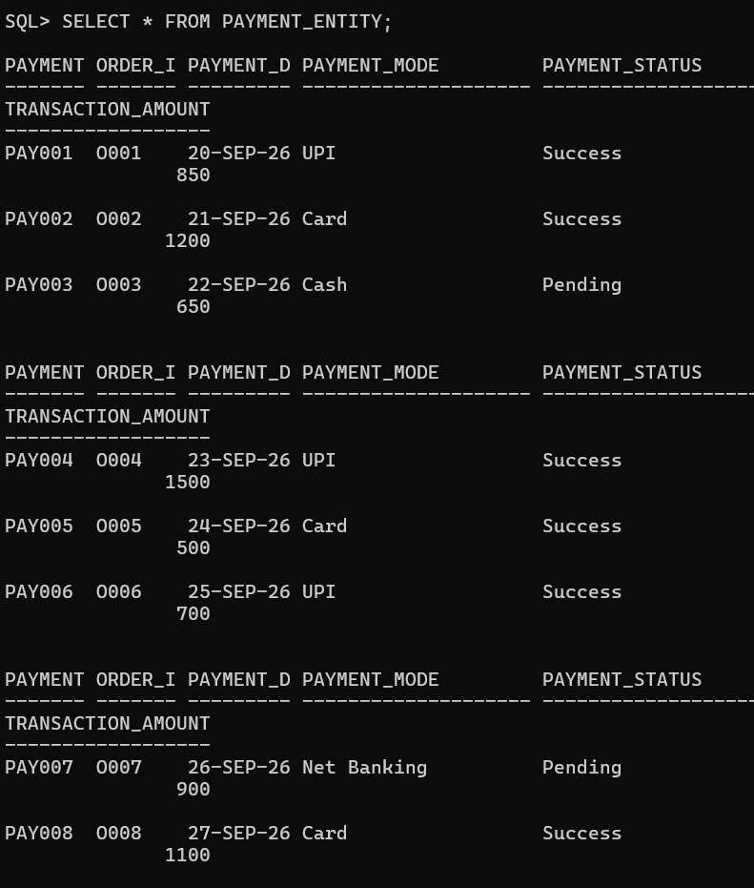
Report1: Display Successful Payments
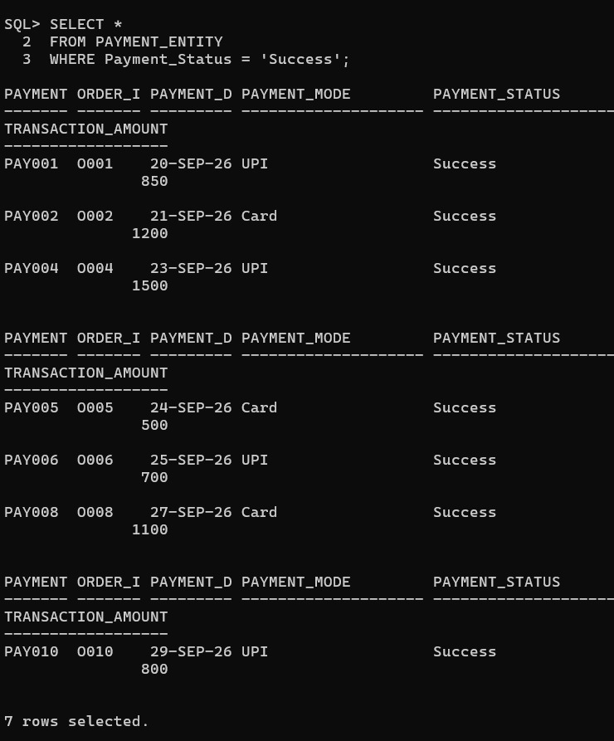
Report 2: Find Failed Transactions
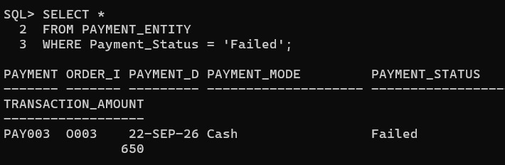
Report3: Count Successful and Failed Payments
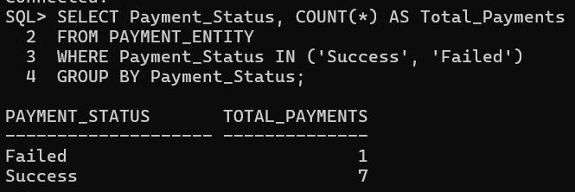
Report4: Update Failed Payment After Retry
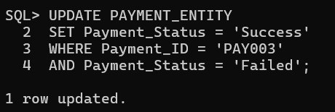
Report5: Identify Pending Transaction
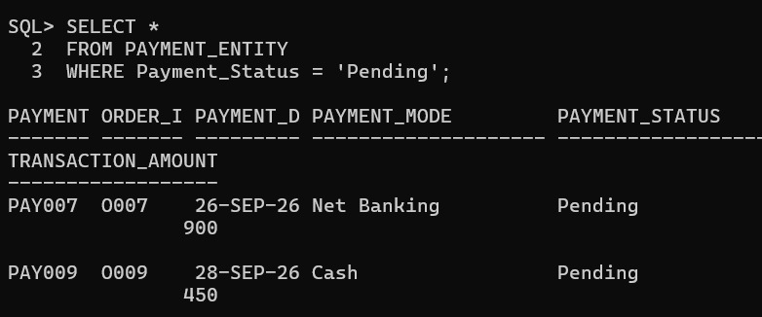

5. Analyse Payment Methods Used by Customers
The payment analysis reports are generated using the PAYMENT_ENTITY table.
Report 1: Payment Mode Analysis
Find:
- Number of transactions using UPI

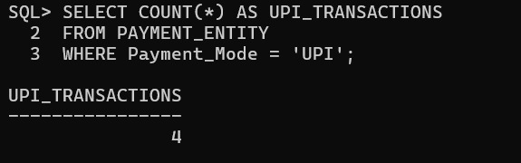
- Number of Card Payments

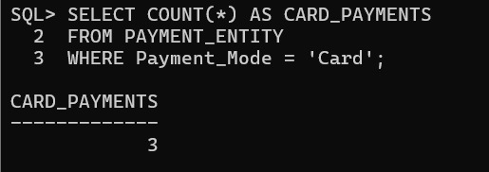
- Most Preferred Payment Method

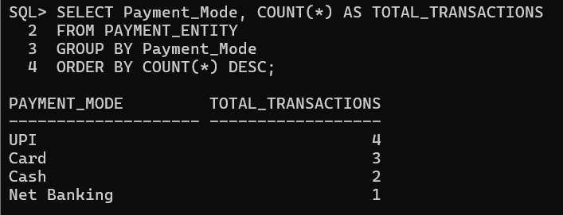

Report 2: Revenue Analysis
Find:
- Total Revenue Generated
- Revenue by Payment Method
3. Average Transaction Amount

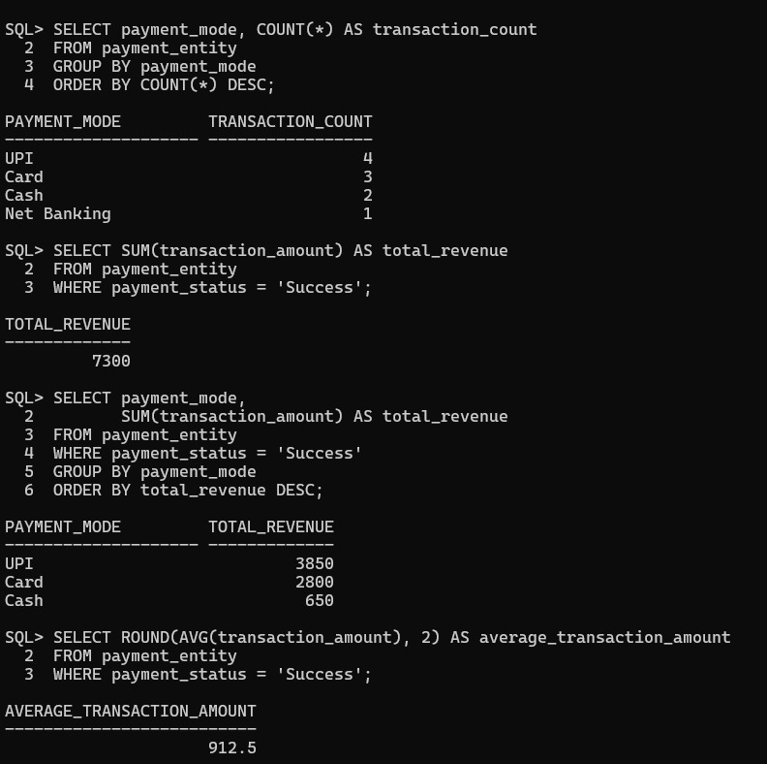
Report 3: Customer Payment History
Display:
- Customer Name
- Order ID
- Payment Mode
- Amount
- Payment Status
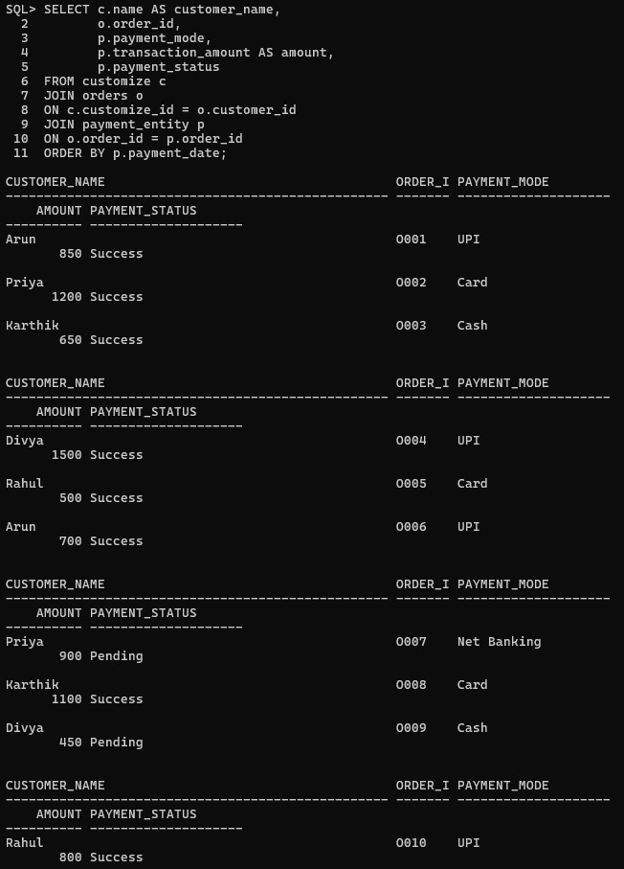
Payment Analysis
